**Calculator Free**

**Linear and Quadratic Functions and Equations**

Time: 45 minutes

Total Marks: 45

Your Score: / 45



**Question One:** **[2, 2, 4 = 8 marks]**

Consider the following Cartesian points (-2, 5) and (1,11)

1. Determine the equation of the line passing through these two points.
2. Determine the equation of a line perpendicular to the line found in part (a) and passing through the point (-6, 4)
3. The line segment consisting of endpoints (*a,b*) and (1,11) has a midpoint of (-2, 5).
4. Determine the values of *a* and *b* .
5. Hence or otherwise determine the equation of the line parallel to the line in part (b) and passing through the point (*a,b)*

**Question Two: [2, 2, 2, 2, 3, 3, 3, 3, 3 = 23 marks]**

Solve each of the following equations, showing all algebraic working.

(a) 

(b) 

(c) 

(d) 

(e) 

(f) 

(g) 

(h) 

(i) 

**Question Three: [3, 2 = 5 marks]**

1. Sketch the lines  and on the axes below.

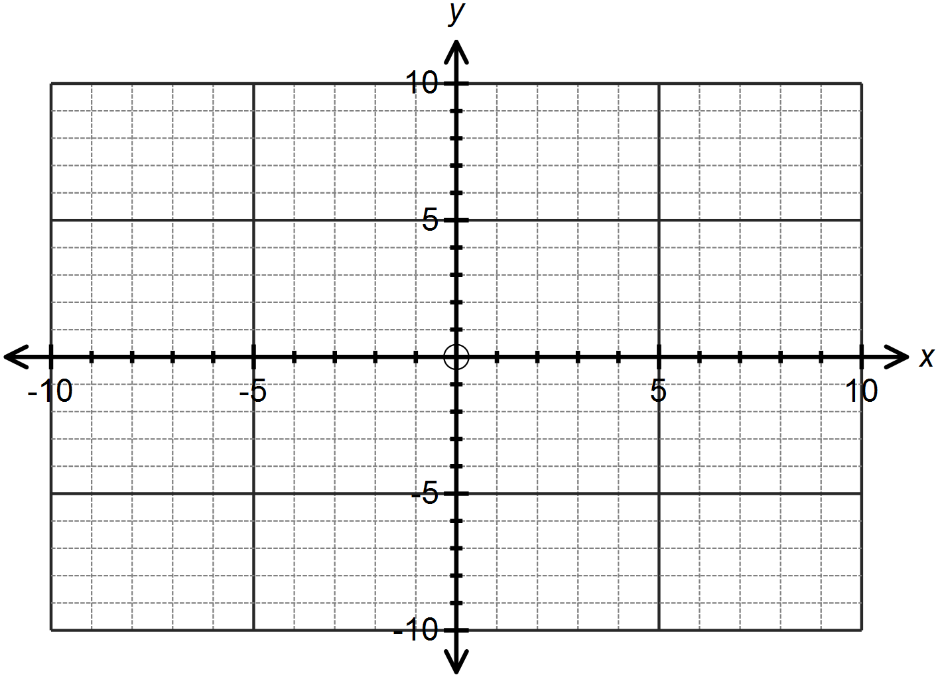

1. 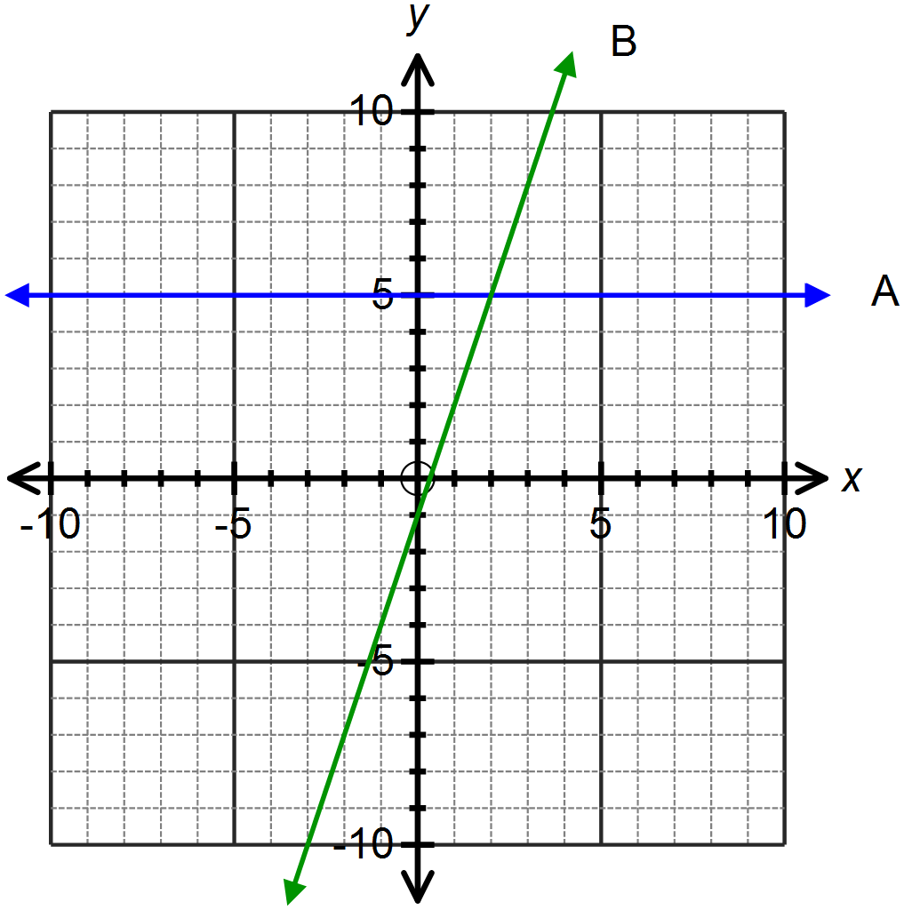Determine the equations of the lines graphed below.

A:

B:

**Question Four: [1, 2, 1, 1, 2, 2 = 9 marks]**

Consider the quadratic function 

1. State the coordinates of the *y-*intercept.
2. Determine the coordinates of the *x*-intercept(s).
3. By completing the square, transform the equation of the function into the form 
4. Hence or otherwise determine the equation of the line of symmetry.
5. State the turning point for this function and its nature.

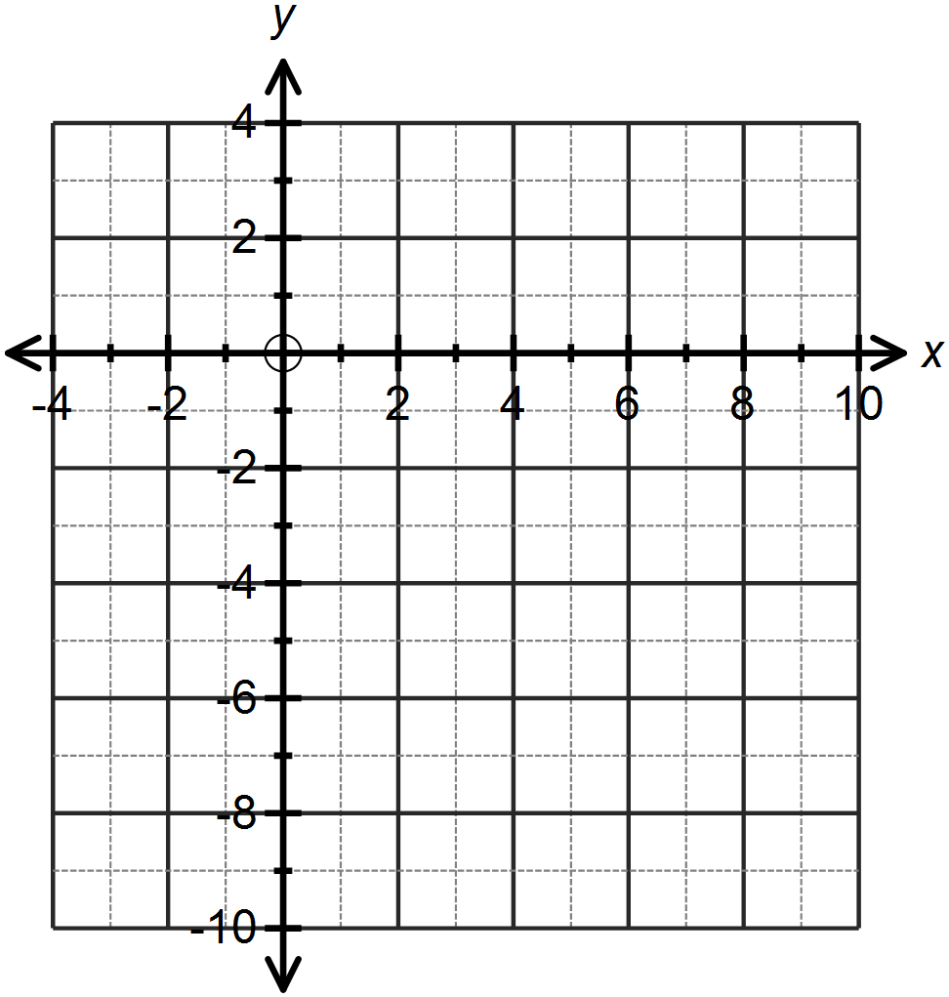

1. Sketch this function on the axes provided.

**SOLUTIONS**

**Calculator Free**

**Linear and Quadratic Functions and Equations**

Time: 45 minutes

Total Marks: 45

Your Score: / 45



**Question One:** **[2, 2, 4 = 8 marks]**

Consider the following Cartesian points (-2, 5) and (1,11)

1. Determine the equation of the line passing through these two points.



1. Determine the equation of a line perpendicular to the line found in part (a) and passing through the point (-6, 4)



1. The line segment consisting of endpoints (*a,b*) and (1,11) has a midpoint of (-2, 5).
2. Determine the values of *a* and *b* .



1. Hence or otherwise determine the equation of the line parallel to the line in part (b) and passing through the point (*a,b)*



**Question Two: [2, 2, 2, 2, 3, 3, 3, 3, 3 = 23 marks]**

Solve each of the following equations, showing all algebraic working.

(a) 



(b) 



(c) 



(d) 



(e) 



(f) 





(g) 



(h) 



(i) 



**Question Three: [3, 2 = 5 marks]**

1. Sketch the lines  and on the axes below.

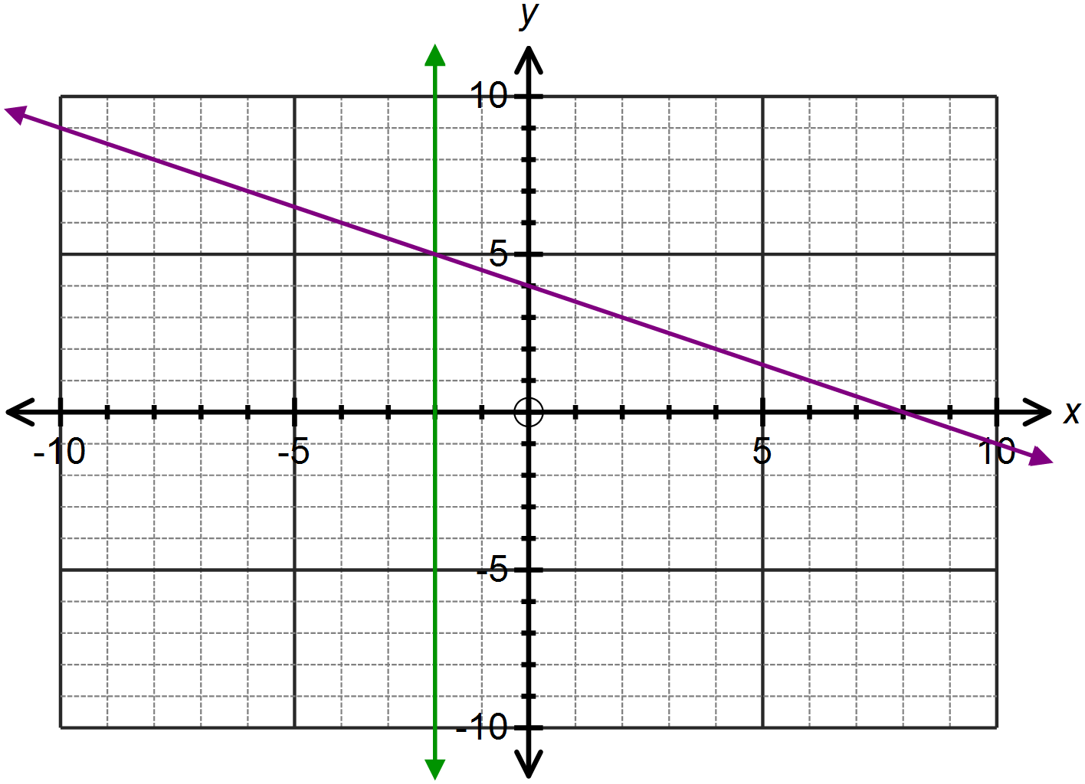





1. Determine the equations of the lines graphed below.



A:



B:

**Question Four: [1, 2, 1, 1, 2, 2 = 9 marks]**

Consider the quadratic function 

1. State the coordinates of the *y-*intercept.



1. Determine the coordinates of the *x*-intercept(s).



1. By completing the square, transform the equation of the function into the form 



1. Hence or otherwise determine the equation of the line of symmetry.



1. State the turning point for this function and its nature.

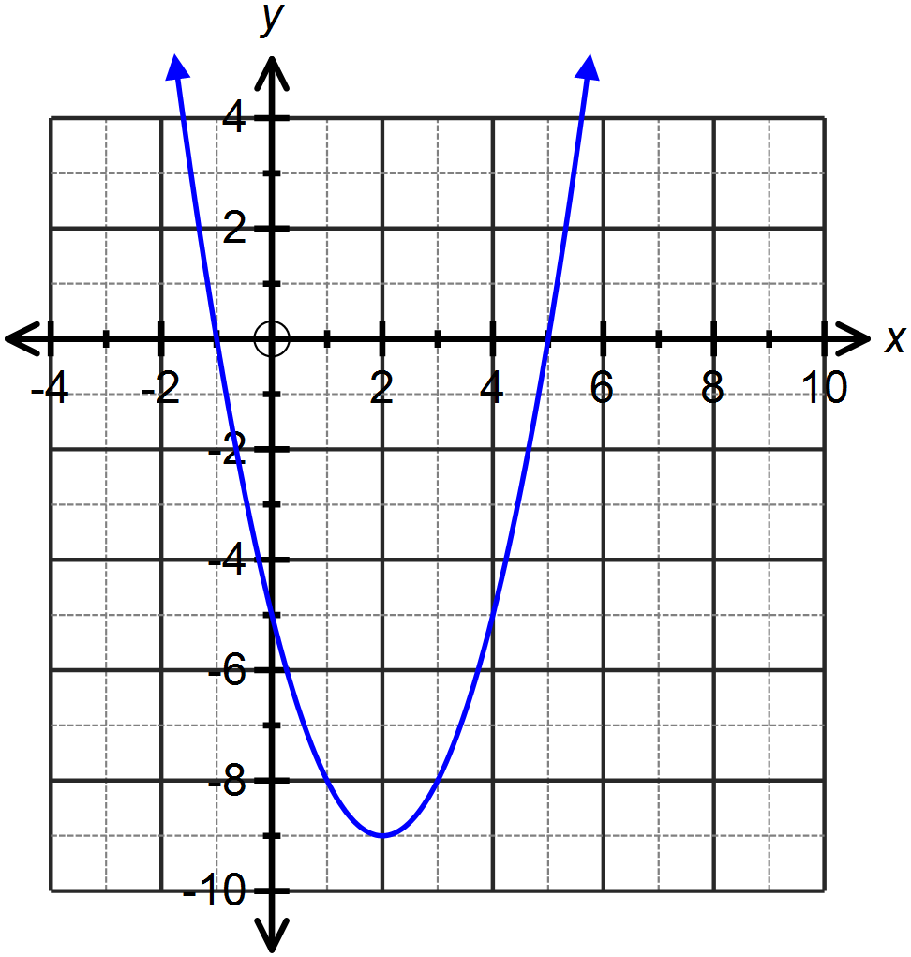

1. Sketch this function on the axes provided.